Guysborough County Community Business Development Corporation Limited
Annual Report
2013 – 2014 April 1 to March 31

Providing Flexible Financing
and Advice to Business

Think Business… Think CBDC

Table of Contents

Introduction 2
Chair & Executive Director’s Message 3

Who We Are 4

Board of Directors 5

Core and Contract Staff 6

What We Offer 9

Core Services 10

Contract Services 13

Partners 14

Communication Plan 15

Investment Performance 17

Moving Ahead 2011-2012 - Market Analysis 19

Projected Outcomes 22

Work Plan 23

Introduction
The Guysborough County Community Business Development Corporation Limited (CBDC Guysborough County) is one of 41 Community Business Development Corporations operating within Atlantic Canada and one of the 13 operating within Nova Scotia. The CBDC’s are non-profit based organizations serving rural Atlantic Canada and supported by Atlantic Canada Opportunity Agency.

The CBDC Guysborough County has a mandate to provide financial and technical assistance through a variety of options including:

- Term loans up to $150,000.00 through CBDC loan products
- Additional term loans to businesses through special CDF funding up to $150,000
- Loans and Bridge financing to non-profit associations up to $150,000 through CDF
- Demand loans through CBDC loan products
- Loan guarantees through CBDC loan products
- Small business counselling (one-on-one and group counselling)
- Delivery Agent for the Self Employment Benefits Program (SEB) funded by Employment Nova Scotia
- Business Training Programs including Entrepreneurial Training Fund
- Operate and administer Careers Nova Scotia Centre funded by Employment Nova Scotia
- Partner with the Nova Scotia Association of CBDCs to deliver the Student in Business Program

Chair & Executive Director’s Message

This year has been a very exciting and busy year for both staff and the Board of Directors. The Guysborough County Community Business Development Corporation Limited has continued to deliver its regular technical and financial programs, the Entrepreneurial Training Fund, the SEB program, the Careers Nova Scotia Center as well as partnering with several organizations to assist in delivering the Student in Business program, Works For You, and Targeted Initiative for Older Workers.
We have met our loan disbursed targets for the year and disbursed 35% more loans this year than last year. We exceeded our disbursed projections by more than 38.5% this year. We have been providing assistance to many existing businesses for modernization and expansion projects so our average loan amounts has increased. As demand for assistance to existing business continues, our site visit and monitoring call numbers continue to exceed projections.
This year we also administered three projects through our Careers Nova Scotia Centre with more than 30 participants graduating.
We wish to thank our partners, the Atlantic Canada Opportunities Agency and Employment Nova Scotia for their continued support as well as the Atlantic Association of CBDCs and the NS Association of CBDCs for their leadership, project development, and marketing initiatives over the past year. We would also like to thank Department of Labour and Workplace Education (Employment Nova Scotia) and Service Canada for their continued support for our various projects. We would also like to express our appreciation to the Board of Directors and staff.
We extend a special farewell to our retiring Community Development Officer, Janice Crooks. Janice was employed with the corporation for 10 years and brought a wide variety of skills and background of communities to her position as Community Development Officer. Her dedication and support will be missed by staff, board members, clients, and community members.
Sincerely,
George Freer, Chair
Wanda MacDonald, Executive Director

Who We Are

We are part of Community Business Development Corporations, a network of 41 independent, not-for profit organizations that work in cooperation with all levels of government and the private sector to meet the needs of small business. CBDC Guysborough County is dedicated to development of small business and assisting entrepreneurs in accessing financing and other business training and resources.

MISSION STATEMENT
“To assist in enhancing our community by expanding and creating skills, businesses and jobs through technical and financial support”.

Local Decision Making
CBDC – Guysborough County is driven by a dynamic volunteer Board of Directors comprised of community leaders and local business people who are sensitive to the needs of our business community. Investment decisions are based on in-depth knowledge of the local markets and business climate.

Board of Directors
2013-2014

George Freer Chairperson – Mulgrave area
Leon Fisher Vice Chairperson – Guysborough/Canso area

Keith Gallant Treasurer – Sherbrooke area
Donald Worth Secretary – Guysborough area
Patricia MacDonald Director – Guysborough area

Anne Marie Rhynold Director – Canso area

Karen Roberts Director – Canso area

Stu Luddington Director – Guysborough area

Leona Wilneff Director – Mulgrave area

Ron Stansfield Director – Sherbrooke area
Paula Farnsworth Director – Sherbrooke/Guysborough area

The board of the Community Business Development Corporation – Guysborough County consists of a maximum of 11 volunteers from the community, who are dedicated to economic development within the County. Criteria for new members include: residing in our coverage area, small business knowledge and/or experience and an interest in community development. The breakdown of the Board of Directors normally consists of three members from greater Canso and area, three members from the Municipality of the District of Guysborough, three members from the Municipality of the District of St. Mary’s and two member from the Town of Mulgrave and area.
Core and Contract Staff 2013-2014

The CBDC Guysborough County staff consists of three full time employees and two contract employees. Last year’s employees are listed below.
Core Staff:
Wanda MacDonald Executive Director
Janice Crooks Community Development Officer
Lisa Doiron Office Manager
Contract Staff:
Dorothy Bennett Employment Coordinator
Kim Avery Employment Coordinator

The Corporation is located at: 46 Main Street, Guysborough, N.S.
The business hours are from 8:30 a.m. to 4:30 p.m., Monday through Thursday and 8:30 a.m. to 4:00 p.m. on Friday.

The mailing address is: P.O. Box 199, Guysborough, NS BOH 1NO
Phone: (902) 533-2770 or 1-888-303-2232
Fax: (902) 533-2016
E-mail: wanda.macdonald@cbdc.ca
Web page: www.cbdc.ca

Core and Contract Staff
Core Staff:
Executive Director
Wanda MacDonald began working with the CBDC as the Youth Intern Development Officer in 1997. Upon completing the Internship she took a term position as the Community Development Officer for the CBDC. This followed with a term position with the RDA and then acting as the Senior Development Officer with the CBDC until becoming Executive Director in April 2003. She has a Bachelor Degree in Small Business & Entrepreneurship and Finance and has experience in community and business development through experience gained at the CBDC and RDA. Wanda has completed several training programs including the NSCC Community Economic Development Certificate Program, the Dale Carnegie Course and the APEC Certified Business Counselor Certificate Program. She graduated with her Masters of Business Administration in CED in May, 2009. Wanda is also a member of the National Association of Parliamentarians and the Human Resource Association of Nova Scotia.

Community Development Officer
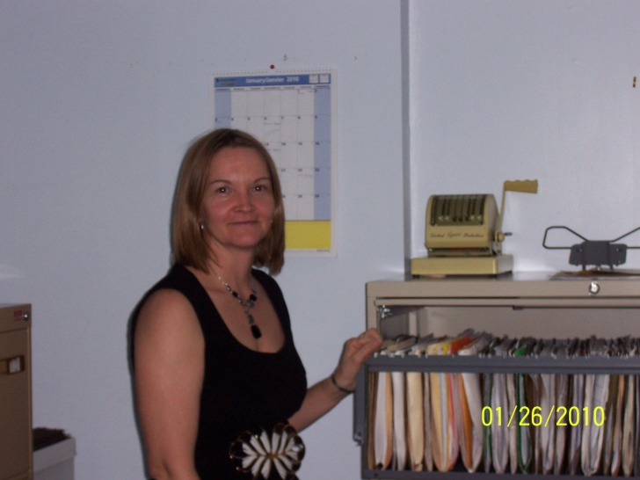
Janice Crooks joined the staff of the CBDC in March, 2004. Janice was previously employed as Project Supervisor for the Skills Transfer Program sponsored by the Guysborough County Regional Development Authority. She was also coordinator for the Guysborough County CAP Network. Janice also worked for Black & MacDonald as cost control coordinator during the construction of the Goldboro Plant. She has a diploma in Office Administration Information Management, the Dale Carnegie Course Certificate and BRIE certification. Janice retired from the CBDC at the end of February, 2014.

Core and Contract Staff
Office Manager
The CBDC’s Office Manager, Lisa Doiron, started working with the Corporation in October, 2009. Lisa’s education includes a certificate in Community Capacity Building and Fundraising. She maintains our computerized services to ensure that the Corporation’s financial files are kept up-to-date. She maintains accurate records and quality control. Along with administration functions, Lisa also performs the majority of the reception and secretarial duties. Lisa had prior bookkeeping experience from her 5 year employment with a private business in Guysborough County.

Contract Staff:
Career Practitioner
Dorothy Bennett started with the Career Centre as the as a Career Practitioner in March 2010. Duties of a Career Practitioner’s include offering employment services in the county via individual interviews, resume & cover letter development, assessments, group training, etc. Dorothy has over 15 years’ experience in Community Development with the provincial and federal government as a Development Officer and Account Manager. She holds a certificate in Community Economic Development from NSCC as well as Project Management designation from St. Mary’s University. Dorothy is a member in good standing of the Nova Scotia Career Development Association.
Career Practitioner
Kim Avery started at the Career & Job Counseling Centre in July 2013 as an Employment Coordinator offering employment services in the county via individual interviews, assessments, group training, etc. Kim has a certificate in Community Based Development from St FX Extension Department. She has 10 years experience in community based development through prior work experience.

What We Offer
CBDC Small Business Loans offer flexible repayment terms designed to meet your individual business needs. . . . .

Core Services:

General Business Loans
Offer financing up to $150,000 in the form of repayable loans, loan guarantees and equity participation.
First Time Entrepreneur Loans target entrepreneurs starting their own business or purchasing an existing business and are in need of start-up capital.
Youth Loans offer financial assistance to youth aged 18 – 34 for business start up, modernization or expansion. Up to $20,000 is available per applicant in the form of a repayable personal loan.

Innovation Loans offer financing for the adoption of innovative technology designed to enhance the productivity and competitiveness of your business.

Social Enterprise Loans offer financial support to non-profit organizations producing goods or services to the market economy, redirecting their surpluses in pursuit of social, environmental or community goals.
Revolving Credit Loans offer a convenient way to access working capital, whether you need to balance out cash flow or respond quickly to a new opportunity.

Community Development Fund Loans offer additional financial assistance up to $150,000 in the form of repayable loans to businesses and offers financial assistance in terms of loans or bridge financing to non-profit associations.

Students In Business (SIB) program is available to students age 15—34, who are presently attending or planning to return to a high school or a recognized post secondary educational institution. The SIB program offers interest free loans up to $5,000.
Contract Services:

Self Employment Options is a program that helps individuals creates jobs for themselves through self-employment. Upon approval for this program, assistance may consist of income support, small business training opportunities and business counseling.

Careers Nova Scotia Centres is a program that offers Career and Employment counseling throughout the County.

Core Services

For many years the Guysborough County Community Business Development Corporation Limited and its predecessor organizations, have serviced clients within the county in a variety of forms, e.g. general financial assistance, preparation of business plans, research, training and general information. We elaborate briefly under various headings, as follows:

Financial Assistance – CBDC

The Corporation offers financial assistance in a variety of manners such as demand and term loans, bridge financing and loan guarantees. Of these, term and demand loans are by far the most prevalent. In 2011, the CBDC introduced loan products including general business loans, first time entrepreneur loans, youth loans, innovative loans, social enterprise loans, revolving credit loans, community development fund loans and student in business loans. Each is detailed on the page prior.
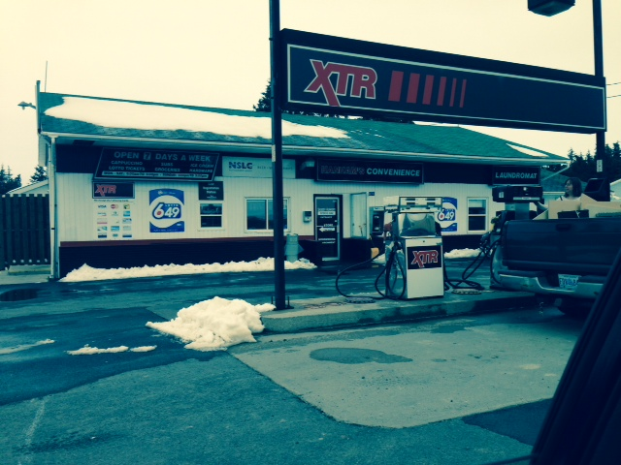
General Business
Youth
FTE
Innovation
Social Enterprise
Total
Number of applications
received by loan product
13
12
13

1

Number of applications
approved by loan product
21
20
22
16

1
2

Number of loans disbursed
by loan product
3
3
4
$169,000

4
4
3
$286,535

Dollar value of loans
disbursed by loan product
$ 452,372
$ 13,346

$ 921,253

Loan Product
0
0
0
0

Hanhams Gas & Convenience
Dave Hanhams

Core Services

Financial Assistance – CDF Loans

The Corporation also offers additional financial assistance in special circumstances to qualifying businesses. Additional term loans up to $150,000 are available. As well, financial assistance of term loans or bridge financing is available to non-profit corporations. This year, we advanced six loans and offered one Letter of Credit through CDF financing.

Technical Services

Technical assistance can take many forms but for the most part involves assistance in business plan preparation, market development research, feasibility analysis, bookkeeping guidance, marketing assistance, financial forecasts, etc. When necessary, staff also provides liaison between the client and other government agencies and other lending institutions.

Business Plan Preparation

All clients applying for financial assistance must complete a business plan to establish viability. Staff works closely with the client assisting them in developing their plan. Counselling assistance is provided. All Staff are trained to ensure they provide adequate counselling rather than consulting. The Executive Director of the CBDC Guysborough County has completed the APEC-IBIZ Small Business Counselling Certificate Program to ensure standard counselling is provided.

Business Counselling Assistance

This is the most common type of assistance and is usually in the form of advice to new or existing entrepreneurs. Counselling assistance may be as brief as a telephone inquiry, or as complicated as credit counselling. Where direct support is available from staff of the corporation, the situation is handled in house. If the client requires more specialized help, we assist with making the necessary arrangements on the clients’ behalf. This year, we provided business counselling services in house to approximately 72 individuals.
Core Services

Training & Entrepreneurial Training Fund

Individual or customized training is available through the Business Development Program’s Entrepreneurial Training Fund (ETF). Leadership Series and skill shops offered last year included the following; computer, excel, social media, business diagnostics, bookkeeping, simply accounting, and quick books. One on-one staff and outside facilitated training is also available. Since 2011, individual entrepreneur or potential entrepreneurs are able to assess funding to support their business management training through the Entrepreneurial Training Fund. This year, the CBDC assisted 6 individuals obtain training through the ETF.
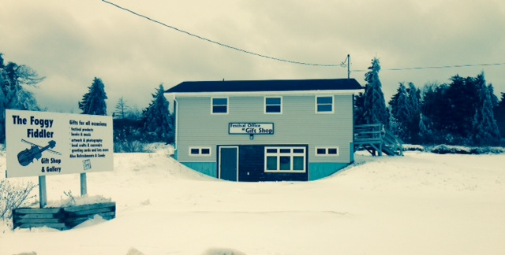
Chedabucto Bay Folk Society
Stan Rogers Folf Festival

Students in Business

We assist in delivering the Student in Business (SIB) Program that enables students to access an interest free loan to start a business. Students are provided with a mentor and are able to access business training and support while running their business. This year, one student from Mulgrave accessed the program to open an Ice Cream Stand.
Contract Services
Self Employment Benefits Program
“The CBDC provided me with assistance through the Self Employment Benefit Program and financing which helped with the start-up of my business.”
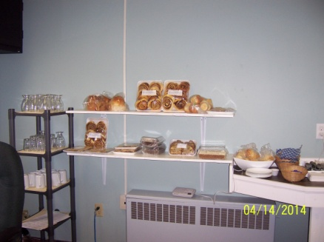
Mary Horne, Harbour View Bakery

The CBDC resumed delivery of the SEB program in June 2008 for Guysborough County. In the past, the CBDC Guysborough County had delivered the SEB program throughout Guysborough and Antigonish Counties.
The SEB program provides a continuation of benefits to qualifying participants while they start their business. Business Training is also provided. Topic of training this year included communication, marketing, customer service, insurance and tax preparation. To date, this contract (ending May 30, 2014), provided 32 orientation sessions and approved four clients who were on the program and monitored monthly.
Staff provides individual training to SEB participants in topics including business planning, budgeting, cash flow, marketing, and pricing.

Bond & Harts Convenience,
Michelle Hart, Owner

Career Nova Scotia Centres

The CBDC has successfully administered the Career and Job Counselling Program (now called Careers Nova Scotia) for Employment Nova Scotia for the eighth year in a row. The Centre is staffed with two full-time coordinators who maintain an up to date job board and assist in wider job searches. One-on-one career counselling is provided by appointment and drop-in services are available.

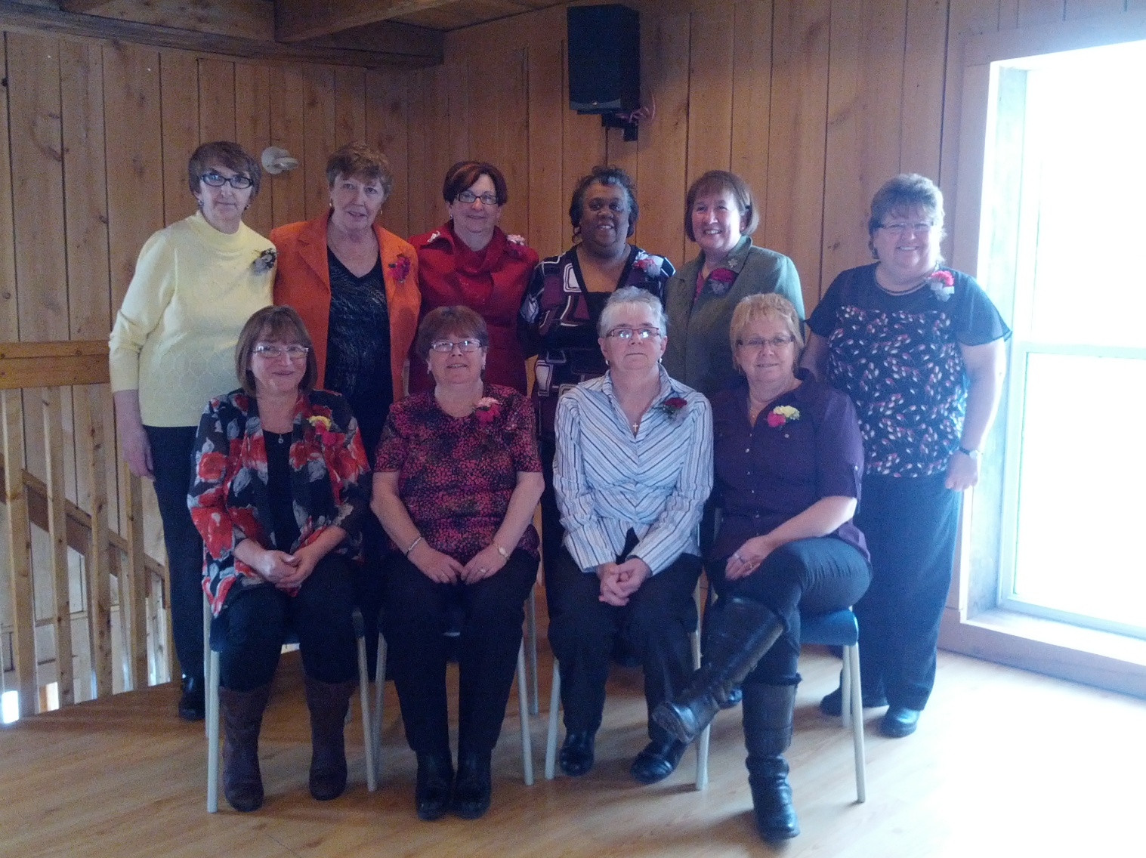
Age Advantage Graduates, January, 2014

Services include resume building, cover letter development, portfolio development, interview skills and preparation, computer and Internet training and networking skills. Several times a year, short-term projects (Older Workers, Skills Enhancement, Skills Link, etc.) are administered through the centre creating additional short-term employment.

Partners

Partnerships
Cooperation with other funding partners is a priority. CBDC Guysborough County maintains open line communication and seeks to partner with chartered banks and credit unions, as well as other lending institutions such as Atlantic Canada Opportunity Agency, Economic Development and Business Development Bank of Canada. We partner and work with other financial institution’s and community organizations with a focus on entrepreneurship and business development in the area including:
- A partnership agreement with the Business Development Bank of Canada.
- Working collectively with the local financial institutions in the area (Commercial Banks, Credit Unions) to partner on projects and make referrals.
- Working closely with the Atlantic Canada Opportunities Agency, The Province of Nova Scotia (OED, NSBI, and ENS) to partner on business and community projects.
- Working with St FX Enterprise Development Centre (XEDC) to promote and deliver entrepreneurship related training programs.

We maintain a good working relationship with other community partners such as: Department of Community Services, NS Business Service Centre, Service Canada, Employment Nova Scotia, Workplace Education, Antigonish/Guysborough Black Development Association, Black Business Initiative, the Department of Fisheries, all municipal units, and many other agencies and organizations.

COMMUNITY SUPPORT
The local community has supported the Guysborough County Community Business Development Corporation Limited since its inception through a voluntary Board of Directors, which the Corporation maintains. It is believed that by utilizing a local board, whose members are aware of what is happening in Guysborough County; we offer services that are of great benefit to the community.

Communications Plan
Summary
The CBDC Guysborough County continues to become more visible within the community. Our goal is to provide more awareness to the community regarding our programs and services. As well, we intend to increase our awareness accentuating the positive with the overall goal being to increase our image positively. Another goal for our communication strategy is to attract performing borrowers from the entrepreneurial base within Guysborough County.

Opportunity Statement
The CBDC Guysborough County is spending more time and resources promoting our programs and services and/or good news stories. Our goal for the next few years is to aggressively promote and advertise our services to the public, our partners, and the community using word of mouth, local newspaper ads, local cable stations, local radio, presentations, and whatever other means are available to staff and the Board of Directors.
Strengths
- Board accepts and promotes the importance of communication
- Strong relationship with the community newspaper, radio, and municipality’s newsletters
- Good relationship with community groups and organizations
- The ability to identify community projects and assist with their development
- The ability to promote programs and services through press releases

Weaknesses
- Lack of financial ability to support a large communications media budget
- Public confusion in government organizations
- Public perception re: foreclosure and loan refusals leads to negativity
- Large geographic area and sparse population discourages business start-ups

The following are targets for our organization:
- Municipal governments – Sherbrooke, Guysborough, and Mulgrave
- Existing business clients throughout the County requiring financing
- Potential new entrepreneurs and community groups needing development assistance
- Existing businesses, existing clients, and non-clients
- Peer lenders such as the Banks, Credit Unions, ACOA, BDC, OED, NSBI, etc.
- Other partners such as BBI, GOALS, GALA, Black Development Association, Disabilities Agency’s and other local development associations.

Communications Plan
Core Message
The core messages that we deliver to specific audiences are:
- We provide non-traditional financing to businesses within Guysborough County;
- We provide technical assistance to our clients during the establishment of their business; and
- We offer a variety of training programs to the business community.

Communications Vehicles
To accomplish the above noted objectives the following steps will be taken:
- To continue to advertise with the theme – CBDC we believe in you.
- To promote ourselves whenever available (job advertisements, radio, media, etc.).
- To advertise in the local newspaper and develop press releases whenever possible
- To continue semi-annual CBDC newsletters.
- To partner with our newspaper more re: business profiles, community sponsorships.
- To communicate with community leaders and other community groups by offering annual presentations on our programs and services or providing our annual report.
- To become involved with community groups as a board member or ex-officio members.

The Communication strategy is as follows:
- To prepare and send our annual report to the Municipal Districts, community organizations, partners, and other interested parties and provide presentations when requested.
- To prepare and distribute an external newsletter at least semi-annually.
- To assist in developing and distributing the Atlantic Community Vision and Provincial Reviews.
- To continue to advertise in the local newspapers, local radio, community cable, municipal newsletters, CAP site network, business cards, mail drops, brochures, flyers and posters.
- To participate in presentations, job fairs, expos and other promotional events.
- Continue to support the Strait Regional School Board through staff judging at the Heritage and Science Fairs when requested.
- Continue to do presentations to entrepreneurship classes in our local schools, when requested.
- Organize board and staff development workshops, when required.
- Continue such promotional methods to include personal mail, direct mail, trade shows, conferences and presentations, toll free number and person-to-person contact.
- Continue to use the CBDC’s logo, slogan, name, business cards and letterhead.
- Maintain presence of the Atlantic Association of CBDCs Web Site.

Investment Performance

This year the CBDC exceeded targets in most performance areas. Loans disbursed are 38.5% higher than projected.
A: INVESTMENT ACTIVITY |  | PROJECTED 2013/14 | ACTUAL  2013/14
# of Investments:
 | a. # of Applications Received | 24 | 21
 | b. # of Applications Approved | 22 | 20
Businesses Assisted: (Disbursed)
 | a. # of New Start-ups | 4 | 2
 | b. # of Existing Businesses | 18 | 20
 | c. Total Businesses Assisted | 22 | 22
Value of Assistance: (Disbursed)
 | a. Terms Loans | 665,000 | 921,253
B. JOBS
Total F/T Equivalents Jobs Created |  | 10 | 12
Total F/T Equivalents Jobs Maintained |  | 40 | 35
Investment per Job
C. OPERATIONAL ACTIVITY
Clients Provided Business Counseling |  | 80 | 72
Portfolio Management
 | a. # of Site Visits | 115 | 131
 | b. # of monitoring calls | 140 | 214
# of Self Employment (SEB) Approved |  | 7 | 4
D. SITUATION AT END OF QUARTER
# of Loans Managed |  | 80 | 93
Value of loans Approved But Not Disbursed |  | 120,000 | 584,818
Investment Performance
This year the CBDC approved and disbursed a record number of loans. The table below lists a summary of this year’s activity compared to the last three year’s activity.
2010- 2011 |  | 2011–2012 | 2012-2013 | 2013-2014
Total Value of CBDC Assistance | $382,879 | $1,322,323 | $743,690 | $921,253
- Number of CBDC Loans | 16 | 36 | 16 | 22
Jobs Created | 12 | 25 | 6
Jobs Maintained | 32 | 70 | 49
CBDC Loans to be disbursed | $155,265 | $85,920 | $406,244 | $584,818
Total Value of CDF Assistance (loan & Equity) | $144,228 | $320,000 | $31,923 | $236,853
- CDF Loans (loan and guarantees) | 6 | 6 | 2 | 7
Value CBDC and CDF Disbursed including to be disbursed CBDC loans | $682,372 | $1,728,243 | $1,181,857 | $1,742,925

This year, in total, we disbursed 27 (20 CBDC and 7 CDF (loans and guarantees)) and committed 8 more CBDC loans to be disbursed totaling $1,742,924. This year’s CBDC investment has created 12 full time jobs and assisted in maintaining another 35 positions. The CBDC has provided managerial assistance on 72 occasions. We also provided 4 SEB clients this year with monitoring, counselling and training.
Investment Performance
 |  |  | 2010/2011 | 2011/2012 | 2012-2013 | 2013-2014
1) | Investments – CBDC
 |  | CBDC Loans Disbursed | 16 (5 SEED) | 36 | 16 | 22
 |  | Value of CBDC Assistance | $382,879 | $1,322,323 | $743,690 | $921,253
 |  | CBDC Loan Guarantee’s | 0 | 0 | 1 | 1
 |  | CDF Loans/Guarantees | 6 | 6 | 2 | 7
2) | Businesses Assisted – CBDC
 |  | New Start Ups | 7 | 9 | 1 | 2
 |  | Existing | 20 | 27 | 18 | 20
3) | Jobs | CBDC
 |  | Total F/T Equivalents – Created (Based on disbursement) | 12 | 25 | 6 | 12
 |  | Total F/T Equivalents – Maintained (disbursed) | 32 | 70 | 49 | 35
4) | Operation | CBDC
 |  | Managerial Expertise | 111 | 118 | 87 | 72
 |  | Number of Site Visits | 130 | 165 | 138 | 131
 |  | Number of Monitoring Calls | 181 | 217 | 199 | 214
5 | SEB
 |  | Clients in SEB program | 8 | 9 | 5 | 4
6 | ECC
 |  | Careers Nova Scotia – Number of Clients Full Time obtaining employment | 19 | 18 | 19 | 26

Moving Ahead 2014-2015:

Market Analysis

Economic Overview
The economy within Guysborough County is struggling as we continue to see a large amount of out-migration. At this time the population within the County is reported to be between 8,000 and 8,500 people.
We are expecting our economy to face many changes over the next few years in regards to major developments. These initiatives will create the shift from reliance on the traditional fisheries and forestry industries to new employment opportunities in Natural Gas, Mining, and Shipping.

Our communities are changing and we are in a position to assist with adapting and dealing with the new challenges and opportunities that we will soon be facing. New opportunities include Goldboro LNG, Melford International Terminals, Sable Wind, and Black Point Quarry.
The CBDC is getting ready for these changes through training and professional development opportunities. The CBDC wants to start now to prepare so we will be in a better position to assist our local businesses in adapting to these changes.

Moving Ahead 2014-2015:

Projected Outcomes

The general outcomes expected at the end of next year (2014-2015) are to accomplish the following:
- Maintained a healthy loan portfolio for the CBDC Guysborough County.
- To have attracted and enhanced a highly skilled entrepreneurial base.
- Maintained and delivered existing financing programs and pursued other programs when opportunities arise.
- Provided counselling, skill development, and other technical services.
- Provided CBDC and CDF financing packages to clients.
- Assisted in the creation and maintenance of jobs.
- Continued delivery of the SEB contract through Employment Nova Scotia.
- Assisted non-profit organizations in developing proposals, applications, etc.
- Maintained strong relationships and on-going communication with our partners (government, non-government, business, organizations, etc.).
- Continued the delivery of the Employment and Career Counselling Service contract through Employment Nova Scotia.
- Implemented new programs as identified.

The tools and measures that are used to evaluate the overall impacts and results accomplished each year will be:
- Our client database of technical assistance provided
- Client survey’s
- Quarterly statistics (actual vs. projected)
- Job creation (actual vs. projected)
- Internal records
- Feedback and input from the Board and staff through public sessions and meetings
- Community input and feedback from training seminars, community meetings, etc.
- A review of the number of new business start ups vs. expansions and modernizations, as compared with the projections
- Measure the rate of success of our loan portfolio

Moving Ahead 2014-2015:

Projected Outcomes

The table below lists the CBDCs quarterly measurable projected outcomes for April 2014 to March 2015 in terms of loan applications, loan approvals, value of loans, as well as a summary of operational activity.

Moving Ahead 2014-2015:
2014-2015 Work Plan

Operational goals and objectives are developed that are achievable and measurable. The CBDC Guysborough County sets operational goals and objectives for the organization and reviews them on an annual basis. The projected operational outcomes in terms of the number of CBDC, CDF, SEB, and Careers Nova Scotia Centre clients assisted are listed in a chart on the following page.

The corporation can achieve its goals through providing service to clients by:
- retention and maintenance of existing clients
- improving our loan approval and rating procedures
- providing financial and technical support to new and existing enterprises
- refining and developing additional revenue generation streams
- increasing our emphasis on marketing and promotion
- providing better efficiencies within the office environment
- continuing to provide business counselling
- providing employment and job related counselling within Guysborough County
- continuing to deliver the SEB program
- continuing to provide outreach services to our youth

Through retention and support for existing clients by efficient collection and monitoring of our loan funds, we will be able to lessen the burden on the allowance for doubtful accounts. The more efficient we become in lending, the more opportunity for long-term sustainability. By providing financial and technical support to new business start-ups and existing businesses we achieve increased loan interest revenue and enhance the overall prosperity of the community. Due to recent economic downturns, we expect the CBDC will be requested to provide additional business counseling and advice to many local existing businesses over the next few years.

Moving Ahead 2014-2015:
2014-2015 Work Plan
A) | Operational Activity |  |  |  |  | 2013/2014
 |  | 1 | CBDC CLIENTS: Counselling
 |  |  | Clients Provided Business Counselling |  |  | 80
 |  |  | CBDC CLIENTS
 |  |  | Clients provided with CBDC Financing Package |  |  | 22
 |  |  | Number of New Business Start |  |  | 4
 |  |  | Number of Existing Businesses Assisted |  |  | 18
 |  |  | Expected Job Created |  |  | 10
 |  |  | Expected Jobs Maintained |  |  | 40
 |  | 2 | CDF CLIENTS
 |  |  | CDF loans disbursed |  |  | 4
 |  | 3 | SEB Clients
 |  |  | Overall Clients (including carry-over) |  |  | 32
 |  |  | Clients placed on full program |  |  | 7
 |  | 4 | Career and Job Counselling
 |  |  | Clients obtaining employment |  |  | 25

For the 2014-2015 year, we expect to disburse a total of $665,000 in CBDC financing packages. We expect to provide more detailed technical assistance and advice to existing businesses due to the current economic conditions. Additional training and assistance will be required. Providing these services will be difficult due to our limited staff. The CBDC has access to Entrepreneurial Training funds that will assist in meeting training needs of our local businesses.

CBDC – Guysborough County
PO Box 199
Guysborough NS
B0H 1N0
(P) 902-533-2770
(F) 902-533-2016
www.cbdc.ca

An ACOA Partner, Serving Rural Atlantic Canada

