Applicant’s Name:

Telephone:

CBDC Central PEI

BUSINESS LOAN APPLICATION

Phone (902) 888-3793  Fax (902) 888-2399
- 11 Water Street,Summerside, PE, C1N 1A2 

BUSINESS INFORMATION
Will this business be a start up? □ Yes □ No Is this an existing business? □ Yes □ No
This business have been operating since (if applicable) How did you learn of CBDC?
Who do you use as your accountant? _
Who do you use as your lawyer? _
This business will be a (check one):
- Proprietorship or Partnership □ Incorporation □ Non-Profit
- Limited Partnership □ Co-op
This business will be operating in the primary sector of (check one):
- Agriculture □ Construction
- Manufacturing □ Social Enterprise
- Aquaculture & Fisheries □ Tourism
- Retail/Service □ Accommodation, Rental & Food Service
- Other: _ _
Business Number Legal name of business is/will be:
Physical address of business
City: Province: Postal Code:
Business Telephone: _ Business Fax
Email: _ Website: _ _
Mailing address of business (if different than above): _ _ _
The business currently has _ full-time employees part-time employees The loan dollars requested will create _ full-time employees part-time employees
List of names(s) and percentage of shares of all principal owner(s) of the business:
First Name Last Name Percentage of shares Telephone
%

%
BUSINESS BANKING INFORMATION
Financial Institution #1: _ Primary Banking Contact:
$ Authorized Amount $ Outstanding Amount $ Repayment Secured? □ Yes □ No Details:
Financial Institution #2: _ _ Primary Banking Contact: _
$ Authorized Amount $ Outstanding Amount $ Repayment
Secured? □ Yes □ No Details:

1
If YES to any of the above, please provide details
- No
- No
- No
- No
Does the business/borrower/spouse/common law party owe any taxes prior to the current year? □ Yes
- Yes
- Yes
- Yes
Has the business/borrower/spouse/common law party ever had an asset repossessed? Has the business/borrower/spouse/common law party ever declared bankruptcy?
Is the business/borrower/spouse/common law party to any claim or lawsuit?

LOAN INFORMATION
This business requires $ _ for its proposed project.

$ will come from the principal owners;
$ will come from the (specify) _; and
$ is requested from the CBDC.
The purpose of the loan is for: | □ Start-up | □ Expansion | □ Maintenance
The breakdown of the total project cost is (specify all which apply):
$ Equipment $ _ _ Leasehold Improvements
$ Inventory $ _ _ Debt Consolidation
$ Working Capital $ _ Land/Buildings
Does the borrower carry life insurance? □ Yes □ No If yes, amount: $_ _
BORROWER’S INFORMATION
Last Name First Name Middle Name Birth Date: MM _ DD _ YY SIN #: Driver’s License #: _ Home Phone: _ Cellular Phone: Email: _ Home Address: _ Mailing Address: _ _
City: Province: Postal Code: _

Marital Status: □ Married □ Common Law □ Divorced □ Single No. of dependents Previous address (if less than 3 years at current address): _ _ _
Do you rent or own your home: □ Rent □ Own How long at this address? years months

If you own your home, please list names on the title:

Last Name First Name

BORROWER’S EMPLOYMENT HISTORY
Current or most recent employer’s name
Employer’s telephone: Salary:
How long were you employed/have been employed here
SPOUSE/COMMON LAW INFORMATION (if applicable)
Last Name
First Name Middle Name
Birth Date: MM _ DD _ YY SIN #: Driver’s License #: Current or most recent employer’s name
Employer’s telephone: _ _ Salary: _ Time employed here _ _

2

PERSONAL FINANCIAL INFORMATION (HOUSEHOLD)
ASSETS
CASH HOLDINGS  (cash, term deposits/GICs, stocks, mutual funds, RRSPs) | Bank | Branch |  |  | Amount ($)
OWNED REAL ESTATE | Physical Address | Year Purchased | Mortgage Holder | Purchase Price | Present Value
AUTOMOBILES | Year/Make/Model | Owner on Title |  | Purchase Price | Present Value
OTHER ASSETS (RV, BOAT, ETC.) | Year/Make/Model | Owner on Title |  | Purchase Price | Present Value
 |  | TOTAL VALUE OF ASSETS |  |  | $$ 0.00
LIABILITIES
BANK LOANS & LINE OF CREDIT | Bank | Branch | Monthly Payment | Collateral Held by Bank | Interest Rate | Balance Owing
 |  |  |  |  | 0.00%
 |  |  |  |  | 0.00%
 |  |  |  |  | 0.00%
BALANCE ON MORTGAGES | Bank | Branch | Monthly Payment | Collateral Held by Bank | Interest Rate | Balance Owing
 |  |  |  |  | 0.00%
 |  |  |  |  | 0.00%
 |  |  |  |  | 0.00%
OTHER LIABILITIES (CREDIT or STORE CARDS,  etc.) | Bank | Branch | Monthly Payment | Collateral Held by Bank | Interest Rate | Balance Owing
 |  |  |  |  | 0.00%
 |  |  |  |  | 0.00%
 |  |  |  |  | 0.00%
TOTAL VALUE OF LIABILITIES |  |  |  |  |  | $  $ 0.00
NET WORTH (ASSETS LESS LIABILITIES) $ $ 0.00

3
REDRESS POLICY
Questions or concerns related to concerns over such things as potential conflicts of interests and potential biases such as those based on gender, age, religion, etc. should be forwarded in writing to the CBDC chairperson.

PERSONAL FINANCIAL INFORMATION (HOUSEHOLD) (Continued)

ASSETS |  | LIABILITIES
Cash  Term Deposits/ GIC | $  $ | Mortgage(s)  Property Taxes | $  $
Mutual Funds | $ | Credit Cards | $
Stocks | $ | Personal Line of Credit | $
Canada Savings Bonds | $ | Department Stores | $
RRSP's |  | Loans | $
Vehicle(s) |  | Rent | $
 |  | Support Payments | $
 |  | Other (Specify) | $
Real Estate |  |  | $
 |  |  | $
Other |  |  | $
-- | �------ | �------------ | _$_

TOTAL LIABILITIES
$

Notes:
Net Worth (Total Assets less Total Liabilities) $

MONTHLY INCOME MONTHLY PAYMENTS
Gross Monthl Income
S ouse's Monthl Income

TOTAL INCOME

$ $

$ Loans $

$ Personal Line of Credit $
$ Credit Cards $
$ De artment Stores $
$ Rent $
$ Su ort Pa ments $

$ $
$ TOTAL PAYMENTS $

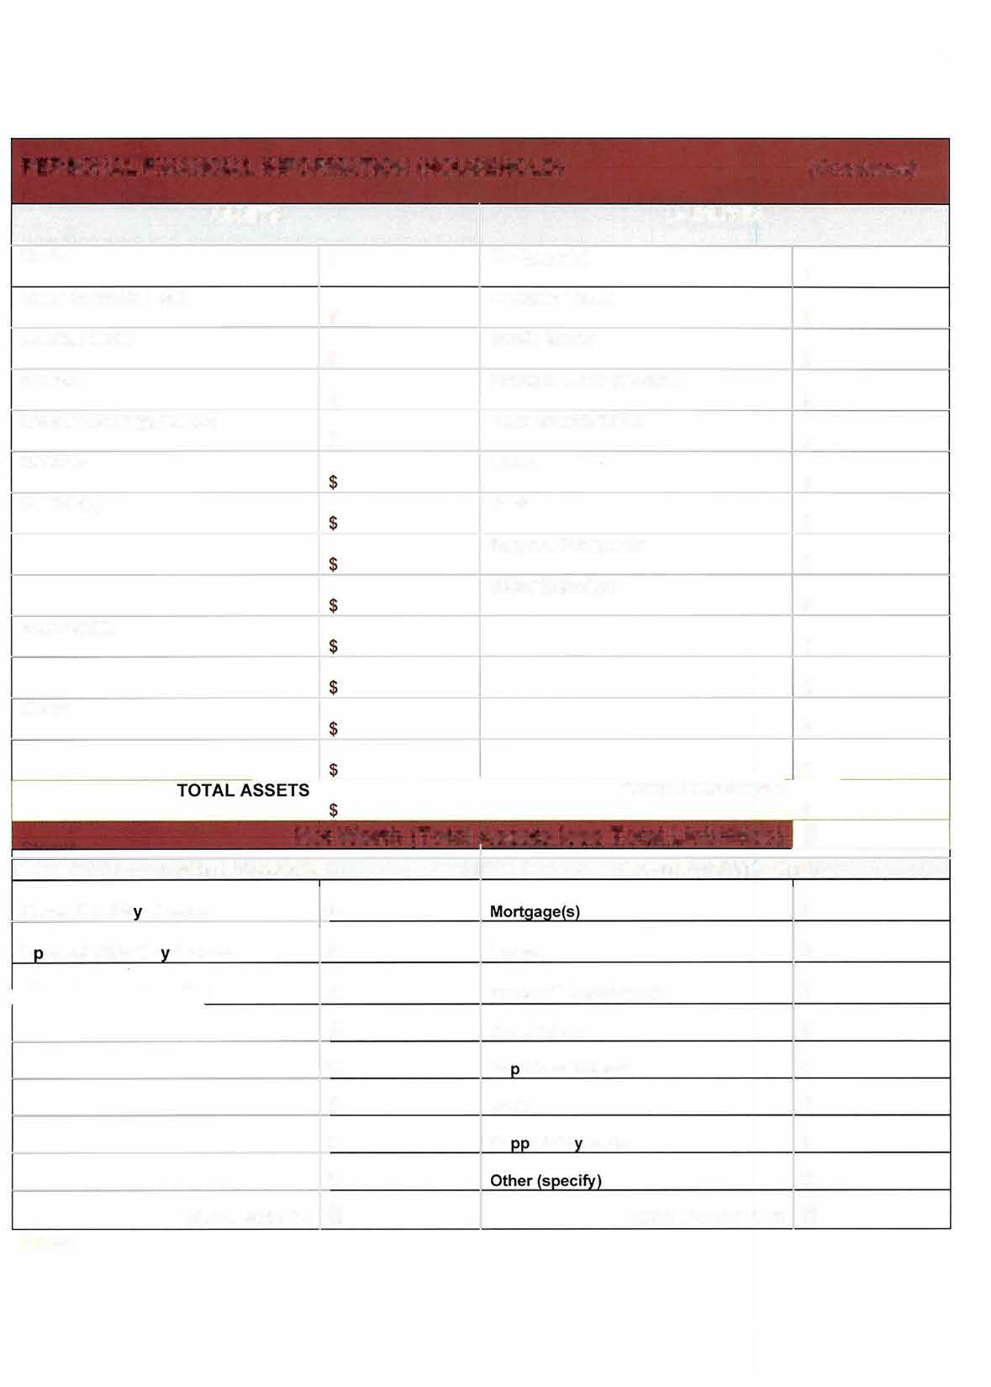

4

PERSONAL INFORMATION
In the course of considering your application for a loan, or any renewal or extension of it, we will collect information about you and your business. This information will include information regarding income, debt, ownership of assets and any other information relevant for the purposes of assessing your application. This information is confidential. Any concerns you may have about your personal information should be addressed to the CBDC.
The CBDC receives funding from the Atlantic Canada Opportunities Agency (ACOA) and certain other government organizations. The terms of our agreements with those organizations require that we maintain the information that we collect for a period of not less than seven years from the date that the application is rejected or the loan, if granted, is repaid.
By signing below you consent to us collecting and using the information referred to above, and to its disclosure to the organizations referred to above, credit reporting agencies and to any person with whom you have or propose to have financial relations.
I hereby consent to this information being collected, used by the CBDC and disclosed to third parties, including, but not limited to, Banks, Caisses Populaires or Credit Unions, credit reporting agencies, insurance companies, lawyers, provincial and/or federal government, accountants, business consultants, training consultants and affiliated CBDCs, for the purpose of facilitating the assessment and approval of my application, as well as facilitating payment of loans, determining my eligibility for assistance programs, and providing me with information about training and development opportunities. I acknowledge having received a copy of the Summary of the CBDCs Privacy Policy. I authorize the CBDC to keep my personal information in my file for a period of 7 years after the last transaction in my file. I, the undersigned, consent to the CBDC’s use of electronic mail to transfer or disclose my personal information, including my financial information to a third party. I understand that email is not entirely secure and that copies of my personal information may be kept by my CBDC’s Internet service provider.

TERMS AND RELEASE STATEMENT - IMPORTANT: Read thoroughly before signing.
If your application is approved will you allow the CBDC to make
a public announcement regarding your business proposal? □ Yes □ No
- The statements made herein are for the express purpose of obtaining financing from the CBDC and are to the best of my/our knowledge and belief true and correct. The applicant understands that additional information, if required in support of this application, must be supplied to the CBDC before adequate consideration can be given to this
application.
- The applicant consents to the CBDC making any enquiries of such persons, firms or corporations, as it deems necessary in order to reach a decision on this application.
- The applicant agrees to reimburse the CBDC any legal costs incurred in the registration of documents for loan security. Should the applicant withdraw a request for funds after legal documents have been registered and cost incurred, the applicant shall be responsible for these costs.
I, hereby agree that if financing is provided to me, for the purpose of the business project described herein, that:
- I shall follow the operation plan to be submitted.
- I shall use the funds received from the CBDC for the purposes intended.
- I shall make changes or alterations to the plan only with written permission of the CBDC.
- I shall maintain insurance as required the CBDC.
Waiver of Claims: Any information provided by the CBDC, its agents, directors, volunteers, and others acting on its behalf is given without warranty or representation as to its accuracy. The CBDC advises you to retain independent lawyers and accountants on any final transaction.

APPLICATION MUST BE SIGNED BEFORE IT CAN BE PROCESSED.
The foregoing information is submitted for the purpose of establishing or maintaining credit with the CBDC and is a true, full and correct statement of my financial condition on the date shown. I hereby authorize the CBDC to obtain any information it deems necessary about me, including but not confined to, reports from credit bureaus, retail credit companies, or any other source that the CBDC deems appropriate.
I, the undersigned, declare that the statements made herein are for the purpose of obtaining business financing and are to the best of my knowledge complete and correct.

Borrower’s Signature |  | Borrower’s Name (Print) |  | Date
Borrower’s Signature |  | Borrower’s Name (Print) |  | Date

*Please provide photo I.D. (Canadian Passport) along with signed application 5

